# SMART HOME AUTOMATION SYSTEM

**Group Members**

|  |  |
| --- | --- |
| Taiba Hussain (Leader) | 02-131222-078 |
| Hafsa Shahid | 02-131222-088 |
| Ruwaida Ali | 02-131222-056 |
| Eeshal Hassan | 02-131222-100 |

BSE 7 C

## Project Definition

A **Smart Home Automation System** is a technology solution designed to automate and remotely control household appliances and systems such as lighting, heating, security, and entertainment devices. It enables users to manage their home environment efficiently and securely using mobile apps, web platforms, or voice commands, often through real-time communication with IoT-enabled devices.

## Vision Statement

For residents who want to make the maintenance and work of the houses easier and better, the Smart Home System is a system which includes all kinds of smart appliances and gadgets that help the resident with their daily lives. Unlike the current existing systems, our product satisfies all the necessary needs of the person with a single system.

## FR & NFR

Functional Requirements:  
1) Light sensors that turn on when a person enters room or opens a cupboard.  
2) Temperature controller for house.  
3) Smart refrigerator which checks what ingredients we need to buy.  
4) Voice assistant.  
5) Air conditioner system with energy saving.

Non-Functional Requirements:  
1) Sustainability  
2) Efficiency  
3) Usability  
4) Performance  
5) Maintainability

## Uml Diagrams

### Class Diagram

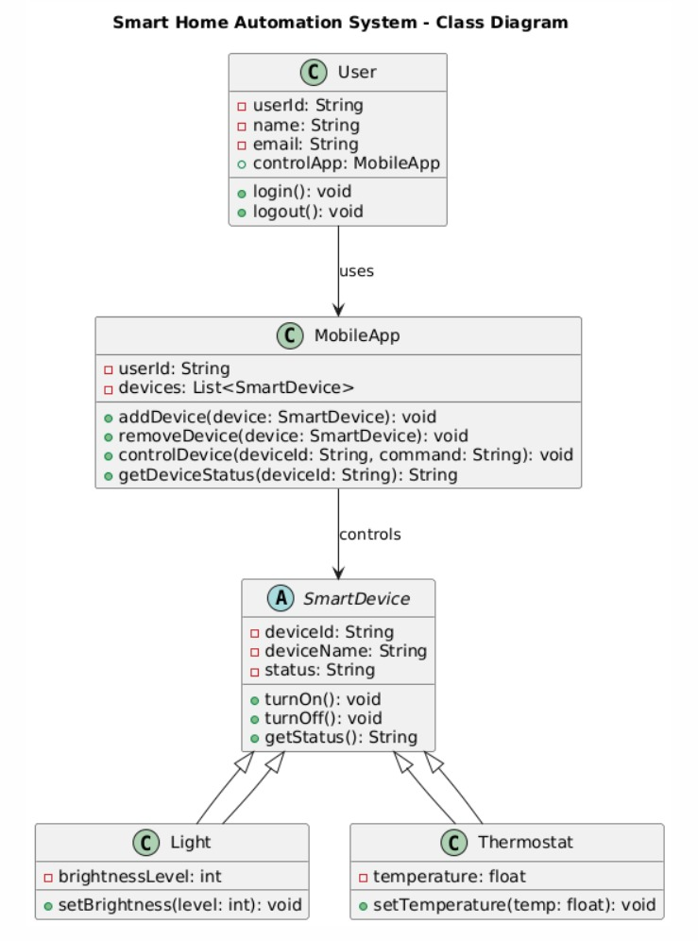

### Sequence Diagram

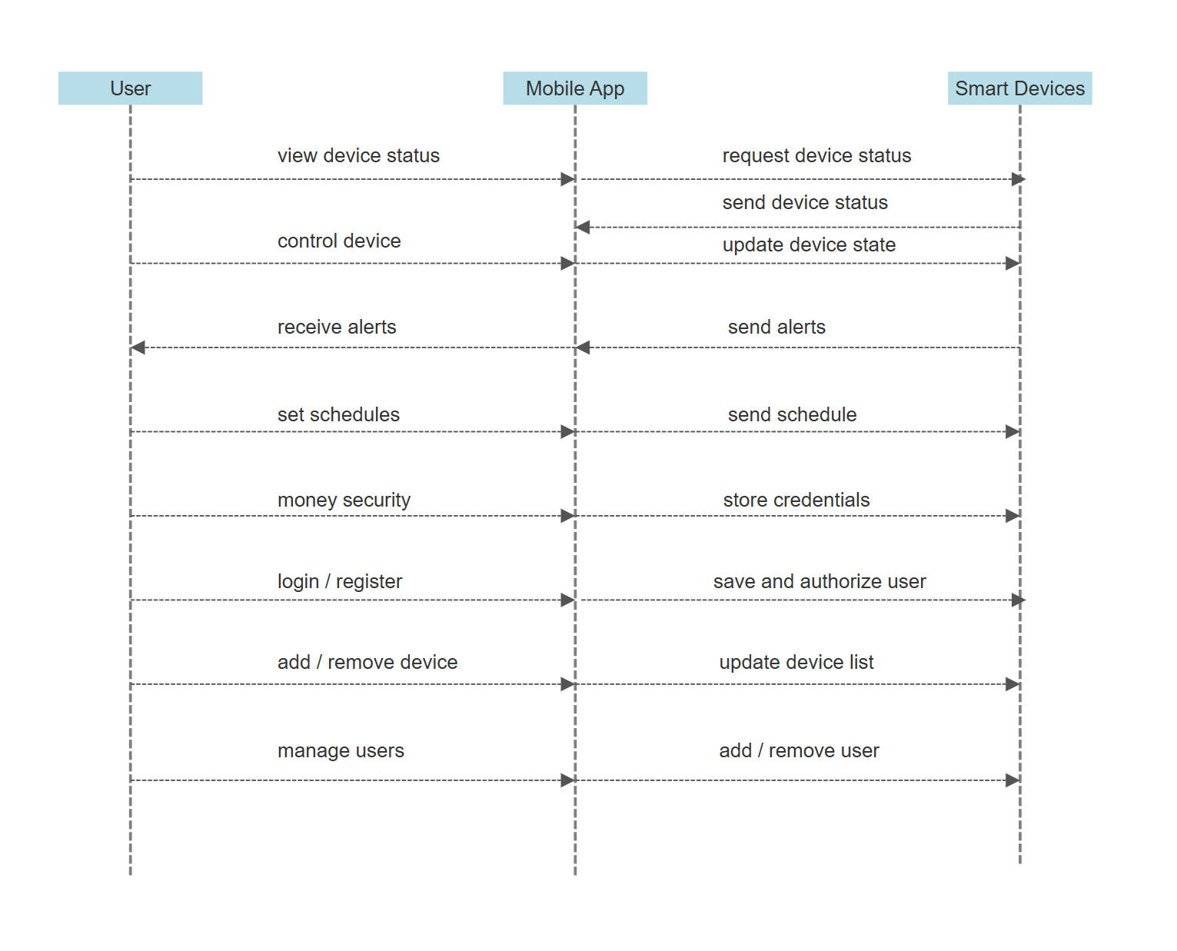

### Context Diagram

### Use Case Diagram

## Low Fidelity Prototypes

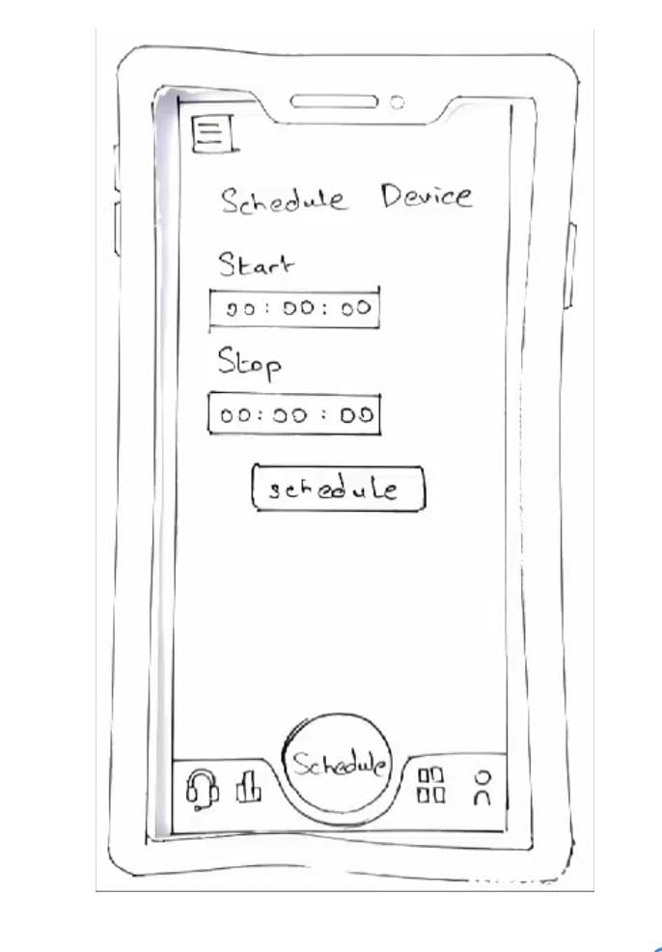

## High Fidelity Prototypes

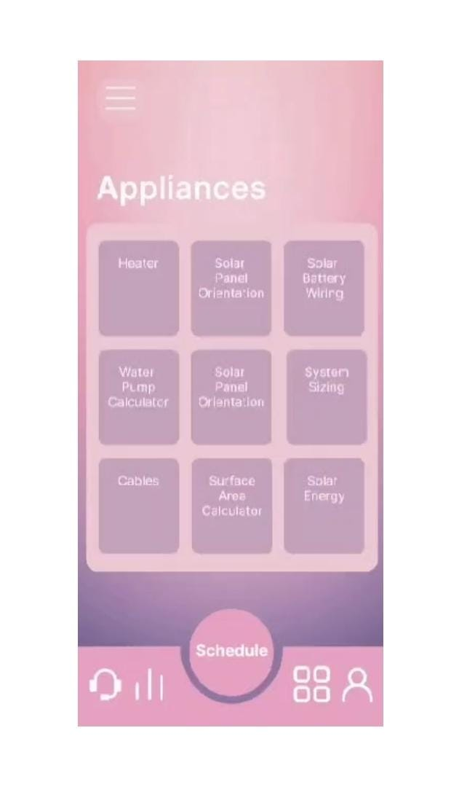

## Github Link

<https://github.com/eesh1234/SHAS>